Date: 20.12.2024
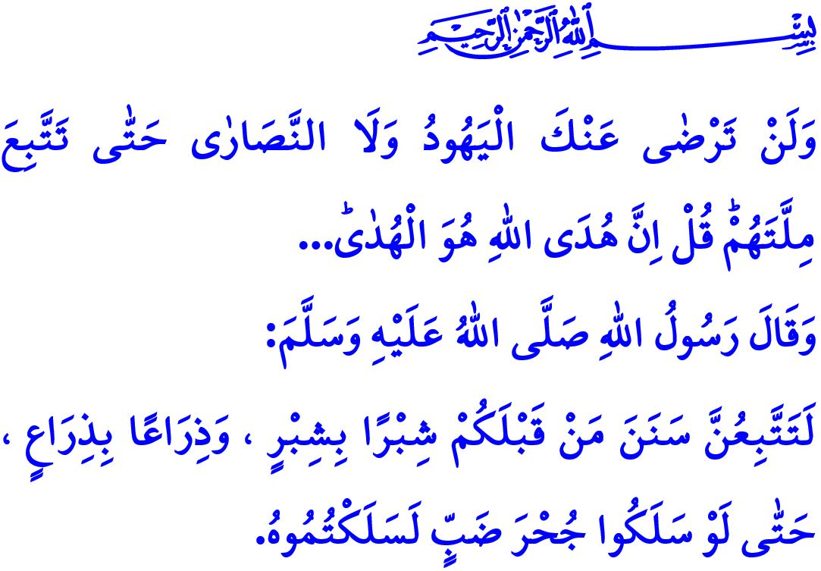
LET US PRESERVE OUR NATIONAL AND SPIRITUAL VALUES
Dear Muslims!
Belief in the prophets is one of the fundamental elements of faith in our sublime religion, Islam. Believing in all the prophets, from the first human and prophet, the Prophet Adam (as), to the final prophet, the Prophet Muhammad Mustafa (saw), is a requirement of our faith. Prophets are the noble messengers of Allah (swt). They were sent to convey the commands and prohibitions of Allah the Almighty to humanity. Humanity has learned to distinguish between truth and falsehood, right and wrong, good and evil through them.
Dear Believers!
Like all the other prophets, the Prophet Isa (as) was also a prophet who conveyed the message of Islam. He likewise conveyed to humanity that there is no deity other than Allah and that servitude and obedience are due solely to Allah. Just as we believe in all the prophets sent by Allah the Almighty, we also believe that the Prophet Isa is a servant and messenger of Allah. As we love all the prophets, we also love him. However, we cannot accept or make a part of our lives any false beliefs, attitudes, behaviors, or symbols that have emerged over time and are attributed to the Prophet Isa but were neither conveyed by him nor approved by Allah the Almighty.
Dear Muslims!
The fundamental element that makes nations strong and carries them confidently into the future is their adherence to their national and spiritual values. Nations that adopt the values of others in place of their own, or embrace foreign symbols instead of their own, cannot stand firm. Societies that forget their own civilization and fall under the influence of foreign cultures lose their history, language, religion, and identity. Indeed, the warning of our Prophet (saw), مَنْ تَشَبَّهَ بِقَوْمٍ فَهُوَ مِنْهُمْ “He who copies any people is one of them.” holds great significance for all of us. For this reason, emulating figures from non-Islamic traditions that have no connection with our religion and tradition, dressing like them, and distributing gifts like them, is against our belief and is wrong.
The birth of a prophet who invited humanity to truth and righteousness cannot be celebrated in a manner contrary to the values he conveyed. Therefore, any form of entertainment or behavior that disregards the boundaries of halal and haram or oversteps the limits of privacy is contrary to our faith and sinful. Moreover, for any reason, exchanging gifts with products sold by those who support the oppressors who kill the innocent is a grave sin that would deeply dishonor the memory of all our martyrs, especially the martyrs of Gaza. Let us never forget that haram acts such as alcohol, which is the root of many evils; gambling, which destroys families; fornication, which undermines the foundations of family and society; narcotic drugs, which render the mind and will powerless; and lotteries and other games of chance, which bring nothing but unhappiness, cannot be made halal or legitimate by any celebration or festivity, including New Year’s celebrations.
Honorable Brothers and Sisters!
The reason Muslims fall into such errors that conflict with their values and beliefs is their worldliness and their distancing from divine principles. Our beloved Prophet (saw) warns us on this matter as follows: “You will follow the wrong ways, of your predecessors so completely and literally that if they should go into the hole of a lizard, you too will go there.” Therefore, let us firmly hold on to the values that define us and keep us steadfast. Let us protect ourselves, our families, our youth, and our children from false beliefs and improper attitudes and behaviors that have no place in our religion. Let us remember that those who fully follow Allah and His Messenger will attain peace in this world and eternal salvation in the Hereafter.
I conclude my khutbah with the meaning of the following verse from Surah al-Baqarah: “Never will the Jews or Christians be pleased with you, until you follow their faith. Say, ‘Allah’s guidance is the only ˹true˺ guidance.’…”

Baqarah, 2/285.
Abu Dawud, Libas, 4.
Bukhari, Anbiya, 50
Baqarah, 2/120. General Directorate of Religious Services

